# JS Advanced Exam Retake

## Problem 1. BookUni

### Use the provided skeleton to solve this problem.

### You can't change directly the given html code.

### Your Task

**Write the** **missing JavaScript code** to make the **Book Store (BookUni)** work as expected:

* When **all fields (title, year and price)** are **filled with correct input**
  + **Title** is **non**-**empty** **strings**
  + **Year** and **Price** need to be **positive** **numbers**

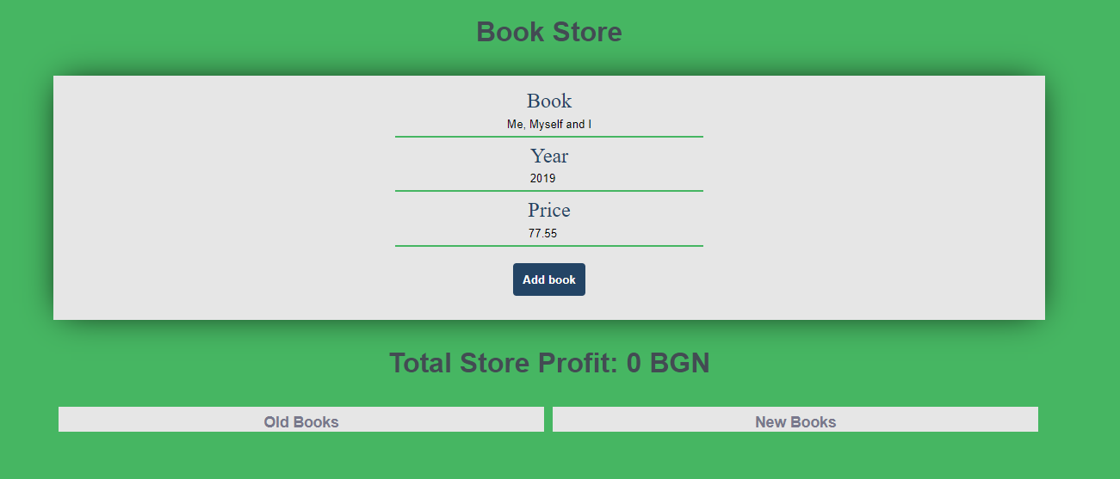

* Upon pressing the **[Add new book]** **button**, a new book should appear in the bookshelf section (**look down the constraints**). Create new **div** **element** with **class** **book** (for every created book) which hold:
  + **paragraph** with text content of the given book title and the given book year in format: **"{bookTitle} [{bookYear}]"**

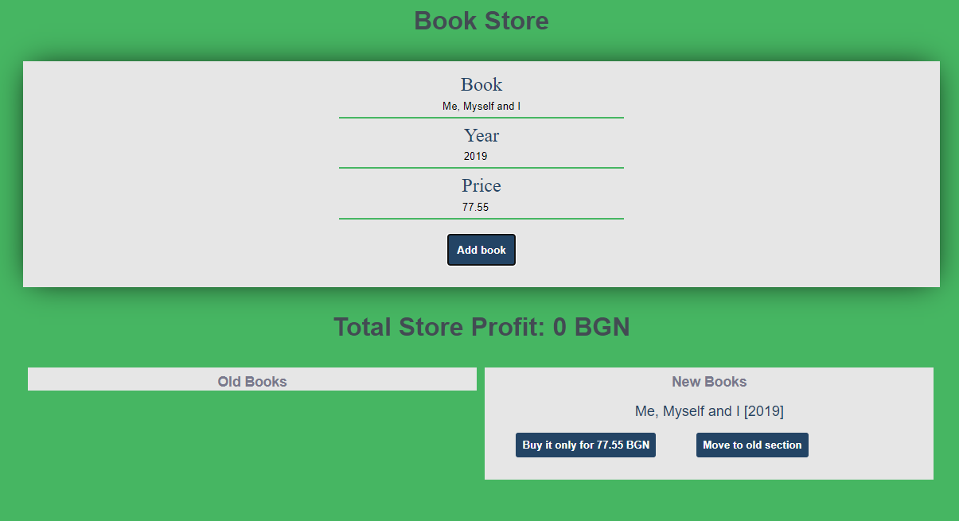

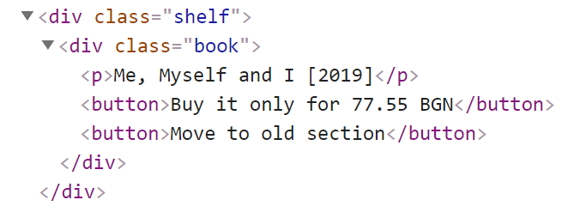

* + **button** with text content "**Buy it only for {bookPrice} BGN**" and **functionality** when is being clicked the **current book should be removed** from the current section and the **total store profit** is **increased** with the given **book price**.

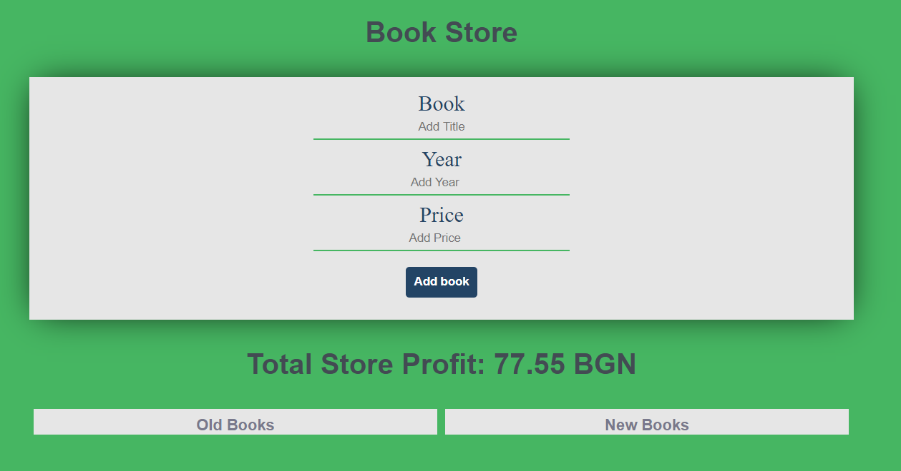

* + (**only applies to new books**) **button** with text content "**Move to old section**" which have the **functionality** when is being clicked the current book should be **moved** from the new books section to the **old books section**.

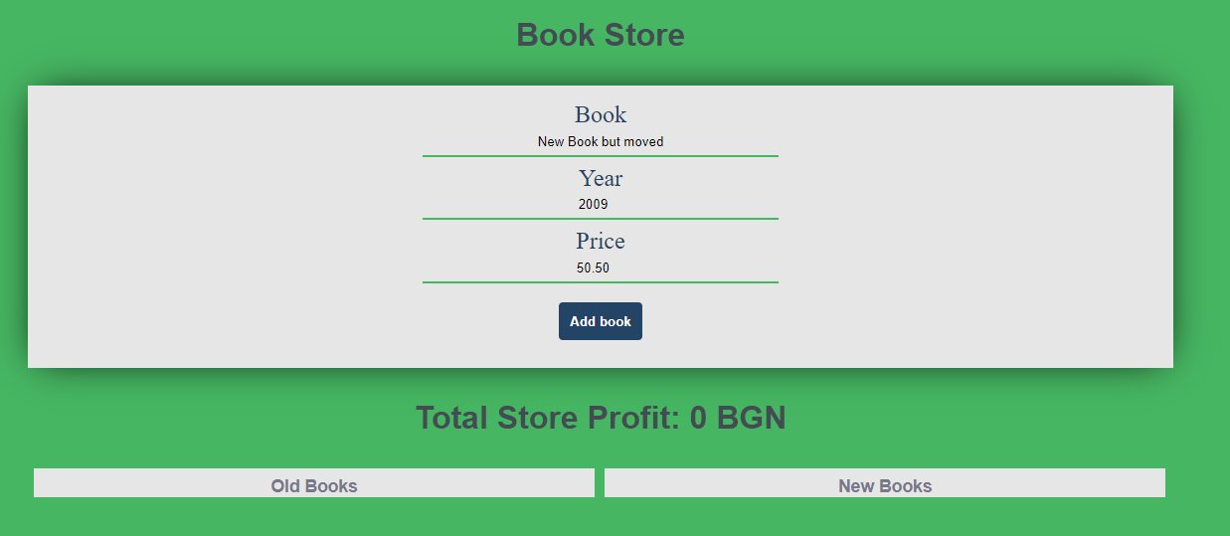

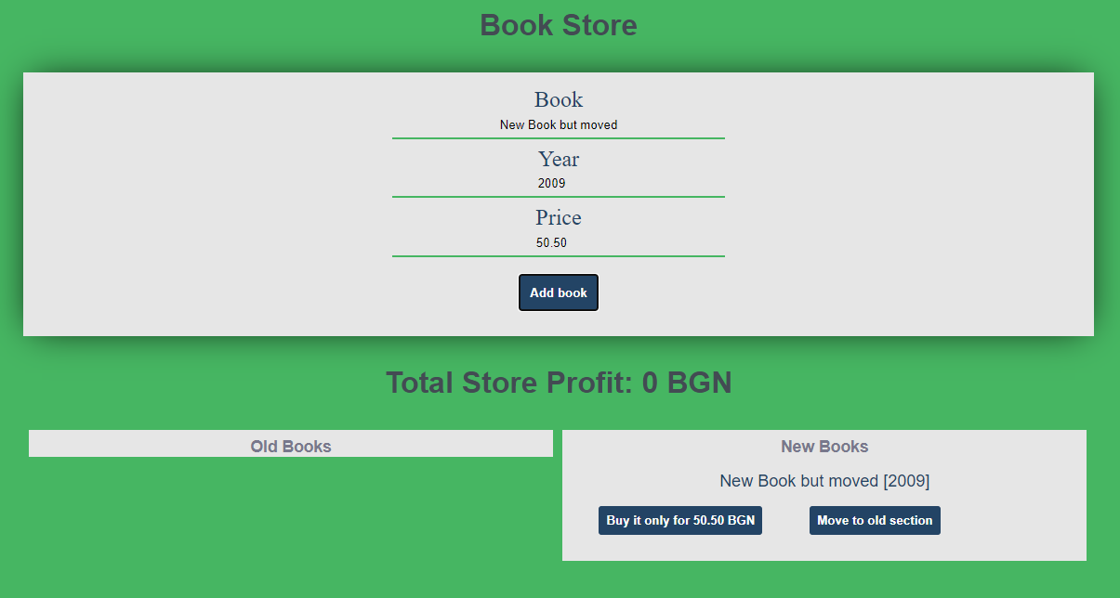

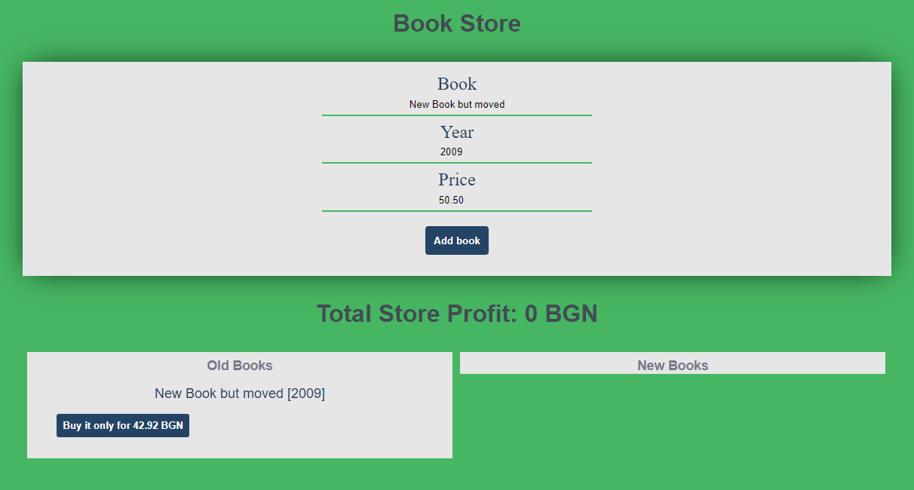

### Constraints

Every price should be **rounded** to the **second** **decimal** **part (toFixed(2))**

Every **old book price** has **15% discount** from the **initial value** (When being **created** into the **old** **books** **sections** or being **moved** from the new books section to **the old books section**)

Each **book's year** **equal** or **higher** than **2000** is consider for a **new book.**

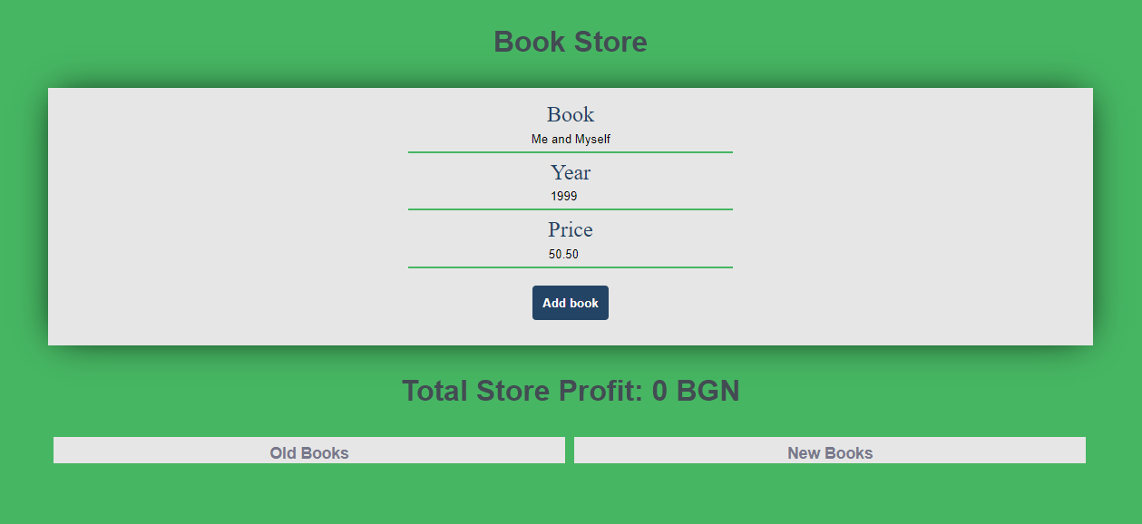

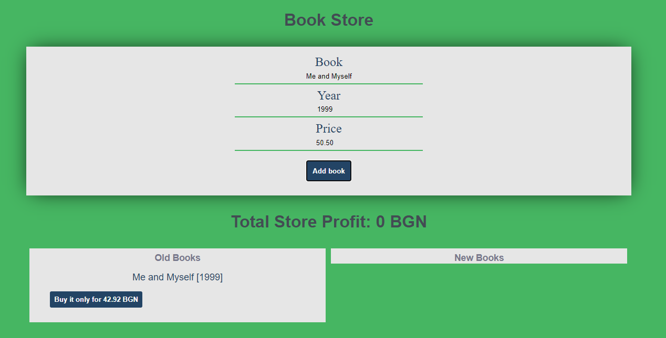

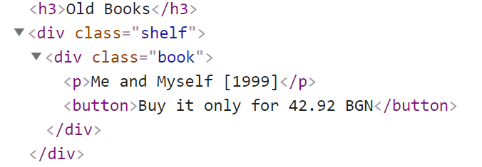

### Submission

Submit only yours **solve()** function.

function solve() {

    const button = document.querySelector('button');

    const title = document.querySelector('input[placeholder="Add Title"]');

    const year = document.querySelector('input[placeholder="Add Year"]');

    const price = document.querySelector('input[placeholder="Add Price"]');

    let sum = Number(0);

    // let newPrice = Number(price.value);

    // let oldPrice = Number((price.value) * 0.85)

    const results = document.getElementById('results');

    const oldBooks = results.children[0].querySelector('div');

    const newBooks = results.children[1].querySelector('div');

    button.addEventListener('click', addBook);

    function addBook(event) {

        event.preventDefault();

        // >=0 ??? ***************

        if (title.value !== "" && Number(year.value) > 0 && Number(price.value) > 0) {

            const p = createEl('p', {}, `${title.value} [${year.value}]`);

            if (Array.from(oldBooks.children).length == 0 && Array.from(newBooks.children).length == 0) {

                const oldDiv = createEl('div', { class: 'book' });

                const newDiv = createEl('div', { class: 'book' });

                oldBooks.appendChild(oldDiv);

                newBooks.appendChild(newDiv);

                if (Number(year.value) >= 2000) {

                    const buyButton = createEl('button', {}, `Buy it only for ${price.value} BGN`);

                    buyButton.addEventListener('click', buyBook);

                    const moveButton = createEl('button', {}, `Move to old section`);

                    moveButton.addEventListener('click', moveBook);

                    newDiv.appendChild(p);

                    newDiv.appendChild(buyButton);

                    newDiv.appendChild(moveButton);

                } else {

                    let oldPrice = Number((price.value) * 0.85)

                    const buyButton = createEl('button', {}, `Buy it only for ${oldPrice.toFixed(2)} BGN`);

                    buyButton.addEventListener('click', buyBook);

                    oldDiv.appendChild(p);

                    oldDiv.appendChild(buyButton);

                }

            } else {

                if (Number(year.value) >= 2000) {

                    const newDiv = newBooks.querySelector('div');

                    const buyButton = createEl('button', {}, `Buy it only for ${price.value} BGN`);

                    buyButton.addEventListener('click', buyBook);

                    const moveButton = createEl('button', {}, `Move to old section`);

                    moveButton.addEventListener('click', moveBook);

                    newDiv.appendChild(p);

                    newDiv.appendChild(buyButton);

                    newDiv.appendChild(moveButton);

                } else {

                    const oldDiv = oldBooks.querySelector('div');

                    const oldBooks = oldBooks.querySelector('div');

                    let oldPrice = Number((price.value) * 0.85)

                    const buyButton = createEl('button', {}, `Buy it only for ${oldPrice.toFixed(2)} BGN`);

                    buyButton.addEventListener('click', buyBook);

                    oldDiv.appendChild(p);

                    oldDiv.appendChild(buyButton);

                }

            }

            function buyBook(event) {

                // let currPrice = Number(price.value);

                let newPrice = Number(price.value);

                document.querySelectorAll('h1')[1].textContent = `Total Store Profit: ${(sum += newPrice).toFixed(2)} BGN`

                event.target.parentNode.remove();

            }

            function moveBook(event) {

                // let newPrice = 0;

                // if (year.value >= 2000) {

                //     newPrice = price.value;

                // } else {

                // newPrice = (Number(price.value) * 0.85).toFixed(2);

                // }

                let oldPrice = Number((price.value) * 0.85)

                const div = createEl('div', { class: 'book' });

                const p = createEl('p', {}, `${title.value} [${year.value}]`);

                const buyButton = createEl('button', {}, `Buy it only for ${oldPrice.toFixed(2)} BGN`);

                buyButton.addEventListener('click', sellOldBook);

                div.appendChild(p);

                div.appendChild(buyButton);

                oldBooks.appendChild(div);

                event.target.parentNode.remove();

            }

            function sellOldBook(event) {

                let oldPrice = Number((price.value) * 0.85)

                console.log(oldPrice)

                document.querySelectorAll('h1')[1].textContent = `Total Store Profit: ${(sum += oldPrice).toFixed(2)} BGN`

                event.target.parentNode.remove();

                // console.log(event.target.parentNode)

            }

            function createEl(type, attributes, text) {

                const el = document.createElement(type);

                for (let key in attributes) {

                    el.setAttribute(key, attributes[key]);

                }

                if (text) {

                    el.textContent = text;

                }

                return el;

            }

        }

    }

}

### Moe решение:

function solve() {

    const results = document.querySelector('#results');

    const output = document.querySelectorAll('h1')[1];

    const newBooksShelf = results.children[1].querySelector('div');

    const oldBooksShelft = results.children[0].querySelector('div');

    let totalProfit = 0;

    const inputs = document.querySelectorAll('form>input');

    document.querySelector('form>button').addEventListener('click', addBook);

    function addBook(event) {

        event.preventDefault();

        const bookTitle = inputs[0].value;

        const year = Number(inputs[1].value);

        const price = Number(inputs[2].value);

        if (!bookTitle) {

            return alert("Please enter book title")

        }

        if (year < 0 || price < 0) {

            return alert("Numbers need to be positive!")

        } else if (!year || !price) {

            return alert("Please enter book year and price")

        }

        if (year >= 2000) {

            //div

            const div = document.createElement('div');

            div.classList.add('book');

            //p

            const p = document.createElement('p');

            p.textContent = `${bookTitle} [${year}]`

            //butBtn

            const buyBtn = document.createElement('button');

            buyBtn.textContent = `Buy it only for ${price.toFixed(2)} BGN`;

            buyBtn.addEventListener('click', buyBook)

            //moveBtn

            const moveBtn = document.createElement('button');

            moveBtn.textContent = 'Move to old section'

            moveBtn.addEventListener('click', moveBookToOldSection)

            div.appendChild(p);

            div.appendChild(buyBtn);

            div.appendChild(moveBtn);

            newBooksShelf.appendChild(div)

            inputs[0].value = '';

            inputs[1].value = '';

            inputs[2].value = '';

        } else {

            const div = document.createElement('div');

            div.classList.add('book');

            //p

            const p = document.createElement('p');

            p.textContent = `${bookTitle} [${year}]`

            //butBtn

            const buyBtn = document.createElement('button');

            buyBtn.textContent = `Buy it only for ${(price * 0.85).toFixed(2)} BGN`;

            buyBtn.addEventListener('click', buyBook)

            div.appendChild(p);

            div.appendChild(buyBtn);

            oldBooksShelft.appendChild(div)

        }

    }

    function buyBook(event) {

        const butnTitle = event.target.textContent;

        let regex = '[0-9]+.[0-9]+';

        let price = Number(butnTitle.match(regex));

        totalProfit += price;

        output.textContent = `Total Store Profit: ${totalProfit.toFixed(2)}`

        event.target.parentNode.remove();

    }

    function moveBookToOldSection(event) {

        const div = event.target.parentNode;

        const priceButton = div.querySelector('button');

        const text = priceButton.textContent;

        let regex = '[0-9]+.[0-9]+';

        let price = Number(text.match(regex)) * 0.85;

        priceButton.textContent = `Buy it only for ${price.toFixed(2)} BGN`

        event.target.remove();

        oldBooksShelft.appendChild(div)

    }

}

### 100/100 Решение

function solve() {

    document.querySelector('form').addEventListener('submit', event => addBook(event));

    const inputs = document.querySelectorAll('form>input');

    const outputs = document.querySelectorAll('.shelf');

    const priceOutput = document.querySelectorAll('h1')[1];

    let totalPrice = 0;

    console.log(priceOutput)

    function addBook(event) {

        event.preventDefault();

        const bookTitle = inputs[0].value;

        const bookYear = Number(inputs[1].value);

        const bookPrice = Number(inputs[2].value);

        if (!bookTitle) {

            return alert('Fille Book Title!');

        }

        if (bookYear < 0 || bookPrice < 0) {

            return alert('Year and Price must be positive numbers!');

        } else if (!bookPrice || !bookYear) {

            return alert('Pleas fill Year and Price!');

        }

        if (bookYear >= 2000) {

            const book = e('div', { className: 'book' },

                e('p', {}, `${bookTitle} [${bookYear}]`),

                e('button', {}, `Buy it only for ${bookPrice.toFixed(2)} BGN`),

                e('button', {}, 'Move to old section'));

            outputs[1].appendChild(book);

        } else {

            const book = e('div', { className: 'book' },

                e('p', {}, `${bookTitle} [${bookYear}]`),

                e('button', {}, `Buy it only for ${(bookPrice * 0.85).toFixed(2)} BGN`));

            outputs[0].appendChild(book);

        }

        inputs[0].value = '';

        inputs[1].value = '';

        inputs[2].value = '';

    }

    document.getElementById('results').addEventListener('click', ev => onclick(ev));

    function onclick(ev) {

        const target = ev.target;

        if (target.textContent.includes('Buy ') && target.tagName === 'BUTTON') {

            const element = target.parentNode;

            let indexS = target.textContent.indexOf('r ');

            let indexE = target.textContent.indexOf(' B');

            let bPrice = Number(target.textContent.slice((indexS + 2), (indexE)));

            totalPrice += bPrice;

            priceOutput.textContent = `Total Store Profit: ${totalPrice.toFixed(2)} BGN`;

            element.remove();

        } else if (target.textContent.includes('Move ') && target.tagName === 'BUTTON') {

            const element = target.parentNode;

            const index = element.children.length - 1;

            element.children[index].remove();

            let indexS = element.children[1].textContent.indexOf('r ');

            let indexE = element.children[1].textContent.indexOf(' B');

            let bPrice = Number(element.children[1].textContent.slice((indexS + 2), (indexE)));

            bPrice = bPrice * 0.85;

            console.log(bPrice)

            element.children[1].textContent = `Buy it only for ${bPrice.toFixed(2)} BGN`;

            outputs[0].appendChild(element);

        }

    }

    function e(type, attributes, ...content) {

        const result = document.createElement(type);

        for (let [attr, value] of Object.entries(attributes || {})) {

            if (attr.substring(0, 2) == 'on') {

                result.addEventListener(attr.substring(2).toLocaleLowerCase(), value);

            } else {

                result[attr] = value;

            }

        }

        content = content.reduce((a, c) => a.concat(Array.isArray(c) ? c : [c]), []);

        content.forEach(e => {

            if (typeof e == 'string' || typeof e == 'number') {

                const node = document.createTextNode(e);

                result.appendChild(node);

            } else {

                result.appendChild(e);

            }

        });

        return result;

    }

}